**Resource**: Resource are the characteristics of server that need to managed over time such as user or package or kernel perameter.

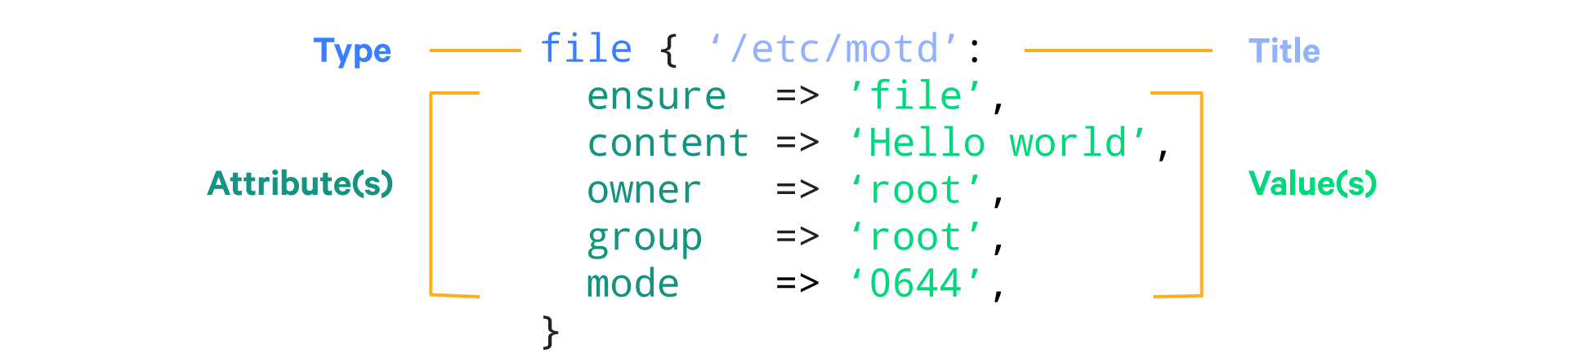

**Type**: is like what kind of configuration required

Ex:file ,cron jobs ,services etc

<https://puppet.com/docs/puppet/6.0/type.html>

**Title**: is the string that refers name of the item refer to target system

Ex :/etc/motd ,/etc/yum.conf etc

**Attributes**: it refers the desired state of the resource

Ex: owner,group,mode ,ensure etc

**Values**: each attribute must have a value

**Cmd**:

|  |
| --- |
| puppet resource file /etc/motd |

|  |
| --- |
| file { '/etc/motd':  ensure => 'file',  audit => ['ensure', 'content', 'checksum_value', 'target', 'owner', 'group', 'mode', 'type', 'seluser', 'selrole', 'seltype', 'selrange', 'ctime', 'mtime'],  backup => 'puppet',  checksum => 'md5',  checksum_value => ,  content => '{md5}d41d8cd98f00b204e9800998ecf8427e',  ctime => '2018-05-07 21:53:43 +0000',  group => 0,  links => 'manage',  loglevel => 'notice',  mode => '0644',  mtime => '2018-05-07 21:53:43 +0000',  owner => 0,  provider => 'posix',  purge => false,  replace => true,  selinux_ignore_defaults => 'false',  selrange => ,  selrole => ,  seltype => ,  seluser => ,  show_diff => true,  source_permissions => 'ignore',  sourceselect => 'first',  type => 'file',  validate_replacement => '%',  } |

Puppet resources are stored in manifest directory with extension .pp

**Puppet lint tool** is used to check manifests compliance with puppet.

### Install It!

|  |
| --- |
| package { 'puppet-lint':  ensure => '1.1.0', provider => 'gem', } |

Or, if you really must:

$ gem install puppet-lint

### Run It!

$ puppet-lint /etc/puppet/modulesfoo/manifests/bar.pp - ERROR: trailing whitespace found on line 1apache/manifests/server.pp - WARNING: variable not enclosed in {} on line 56*...*

### Fix Them!

$ puppet-lint --fix /etc/puppet/modulesfoo/manifests/bar.pp - FIXED: trailing whitespace found on line 1apache/manifests/server.pp - FIXED: variable not enclosed in {} on line 56*…*

Or you can use puppet validator “https://validate.puppet.com/”

Or

Cmd

|  |
| --- |
| Puppet parser validate test.pp |

Resource Relationships attributes

Before – need to run before resource

Require- executes dependent resource before executing a resoarce

Notify –restarts if anything changed used for service notify => service[puppet]

Subscribe-restarts anything changed used for file subscribe => file[xyz

### Glossary

**Declarative Language:** A style of coding that describes the end result, without the steps of how to do it. [You can learn more about declarative languages and why they are so great here](https://www.netguru.co/blog/imperative-vs-declarative).

**Resource:** Something on a server you would like to manage. [Learn more about resources here](https://puppet.com/docs/puppet/latest/lang_resources.html).

**Attribute:** A manageable configuration for a resource. For example, the owner of a file. [Here’s a more in depth explanation of attributes.](https://en.wikipedia.org/wiki/Attribute_(computing))

**Node**: A single machine that uses Puppet. For example, your laptop could be a node. An individual server could also be a node. [Here’s some more info about Puppet Nodes.](https://puppet.com/docs/puppet/5.0/lang_node_definitions.html)

**Syntax Validation:** Checking that your code is in the right format without checking what it’s actually doing. [You can learn about Puppet Syntax here](https://puppet.com/docs/puppet/latest/style_guide.html).

**Facts:** Information about a specific node written in the form of a key-value pair. This information might include the operating system being used, the IP address, or whether or not it is a virtual machine. [Learn more about facts here](https://puppet.com/blog/fact).

**Array**: An array is a series of values that looks like [‘one’, ‘two’, ‘three’], denoted by square brackets. [Learn more about arrays here.](https://techterms.com/definition/array)

**Hash:** A hash is a series of key-value pairs that looks like { ‘a’ => ‘A’, ‘b’ => ‘B’, ‘c’ =>‘C’ } denoted by curly braces. [Learn more about hashes here.](https://www.techopedia.com/definition/25432/hash-code)

**Directory:** In computing, a directory is a catalog containing related files, also sometimes called a folder. A directory can contain other directories (known as subdirectories). These are typically referred to as having a parent-child relationship, with the top-most directory being referred to as the ‘root’. [Learn more about directories here.](https://en.wikipedia.org/wiki/Directory_(computing))

**Symlink:** Also known as a symbolic link, or a soft link. A symlink points to the entry that contains the data; it does not contain the data itself. [Learn more about symlinks here.](https://en.wikipedia.org/wiki/Symbolic_link)

]